Blog 9

After the whole website is finished, I try to look back the design of the whole website and polish it to make it look nice.

I removed the border color of the header and the wrapper, I put border color when I was making the website so I can see the position of them and easier for me to move them around. I can take them away after I have finished the website. But I think is too plain after I take the border color away, so I put a separate line image under the header.

I added some comments on the HTML code so the other code readers can understand what I am doing in that part. This practise is also good for long-term website maintenance since the website may need to be updated in the future and this task maybe done by another person, putting comments in the code is easier for the code reader to understand the purpose of that part of code. I also erased the unnecessary codes in the CSS. Some codes I put in the CSS were to test whether it can work or do what I want it to be, I had found the solution eventually so the redundant code I commented out can be deleted to keep the codes clean and tidy. The code in the CSS I tried to organise them in order with the HTML code, for example, the wrapper and the header are the first two things in my HTML, so I put code of the body, wrapper, and the header in CSS at the very beginning; and I put the same group of code together, like the navigation bar, the code of the whole nav bar, the buttons on it, and the code of hover on the buttons are put in the same group together.

I add an <a>tag in the social media icons in the footer, so it links to the social media websites in a new window tab. I am trying to get a higher ranking in search engine that’s why I do that. And I add opacity property when the user hover the icons so it will look nicer.

I added photo description to all my alt in the <img> tags, if the user’s internet speed is not fast enough to load all the pictures, the user can still able to know what information is showing in that image. It can create a better user experience

I attempted to make a responsive website. I downloaded Bootstrap Studio from Github Education, but then I realised this is for building a new responsive website for scratch, it is not allowed me to open an existing folder where contains my finished website. So I researched how to make a responsive website from HTML and CSS and tried to make it responsive.

These are the codes I put in on the home page:

@media only screen and (min-width:480px){

    header h{

        font-size: 4rem;

    }

    header img{

        height: 3rem;

        width: 22rem;

        margin-top: -1.8rem;

    }

    nav{

        height: 3rem;

        overflow: hidden;

        text-align: left;

    }

    nav ul li{

        font-size: 1.3rem;

        padding: 0;

    }

    .content{

        font-size: 1rem;

    }

    .container{

        height: auto;

    }

    .indoor{

        width: 47%;

        height: 13rem;

        margin-left: 0;

    }

    .outdoor{

        width: 47%;

        height: 13rem;

    }

    .left{

        width: 33%;

        text-align: left;

    }

    .middle{

        display: block;

        width: 37%;

    }

    .right{

        margin-left: 10px;

    }

}

These are the result I got:

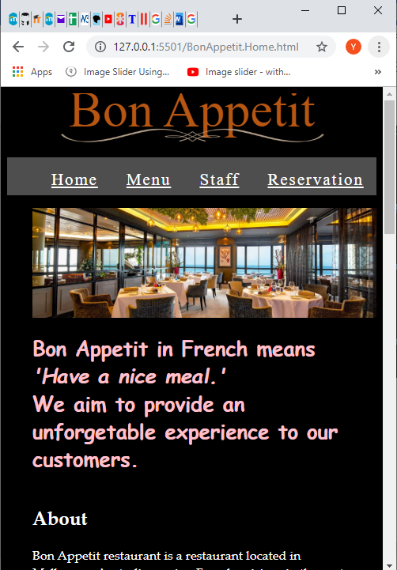



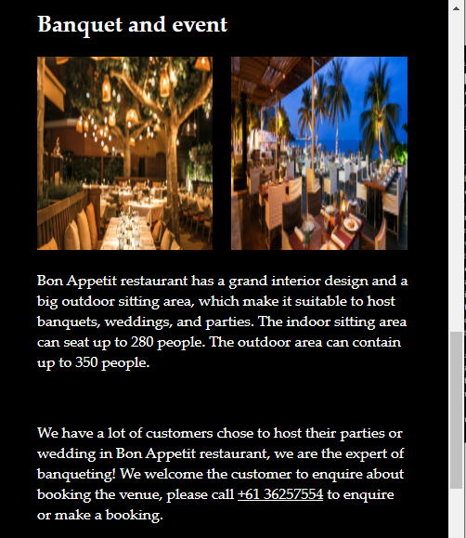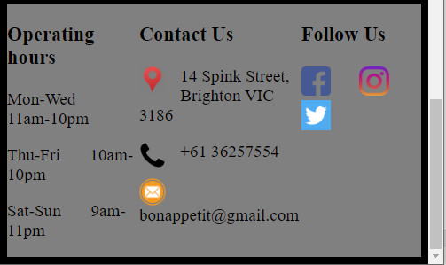

If I do “@media only screen and (min-width:480px)”, I can change the layout to mobile phone size but it will keep the mobile phone layout even I widen the browser into laptop size which is not what I want.

If I change the code to “@media only screen and (max-width:480px)”, it would not change anything to mobile phone layout. This is the problem I could not fix, so I decided to comment this code out on the BonAppetit.Home.CSS file, just using the origin laptop layout design on my browser.